TERRAFORM OUTPUT **VALUES**

In Terraform, output values are used to export specific values from a module, a set of resources, or the entire Terraform configuration. Output values can be useful for passing data between Terraform modules,

displaying values that have been created or modified by a Terraform configuration, or exposing values for use in other tools or scripts.

When you define an output value in Terraform, you specify the value that should be returned when the output is accessed.

**output:** This keyword is used to define an output value in Terraform.

**<output_name>:** This is the name of the output value. It should be a unique identifier that can be used to reference the value in other parts of the Terraform configuration.

**value:** This keyword is used to specify the value that should be returned when the output is accessed. This value can be a specific attribute of a resource, the result of a calculation, or any other value that can be represented in HCL.

**[description = <description>]:** This is an optional keyword that can be used to provide a description of the output value. The description can be helpful for other developers or users who are working with the Terraform configuration.

**[sensitive = <bool>]:** This is an optional keyword that can be used to mark the output value as sensitive. If the value is marked as sensitive, Terraform will obfuscate the value in the console output and logs to prevent accidental exposure of sensitive data.

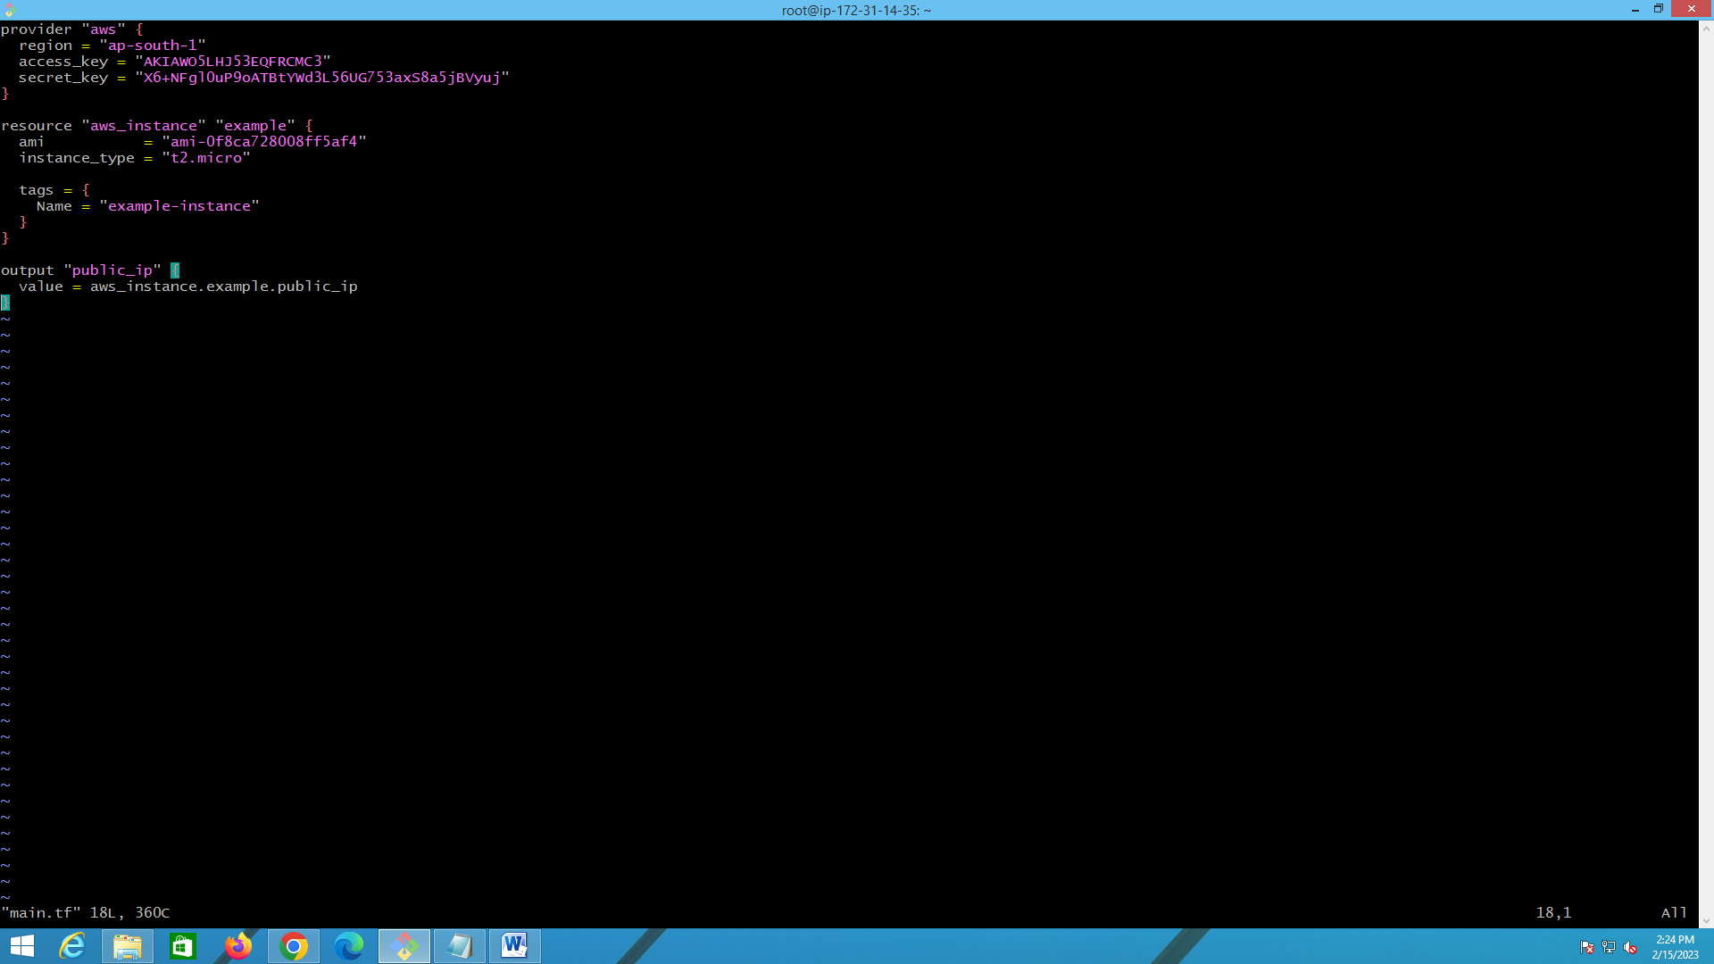

If you want to display some text in output values.. you can use like this

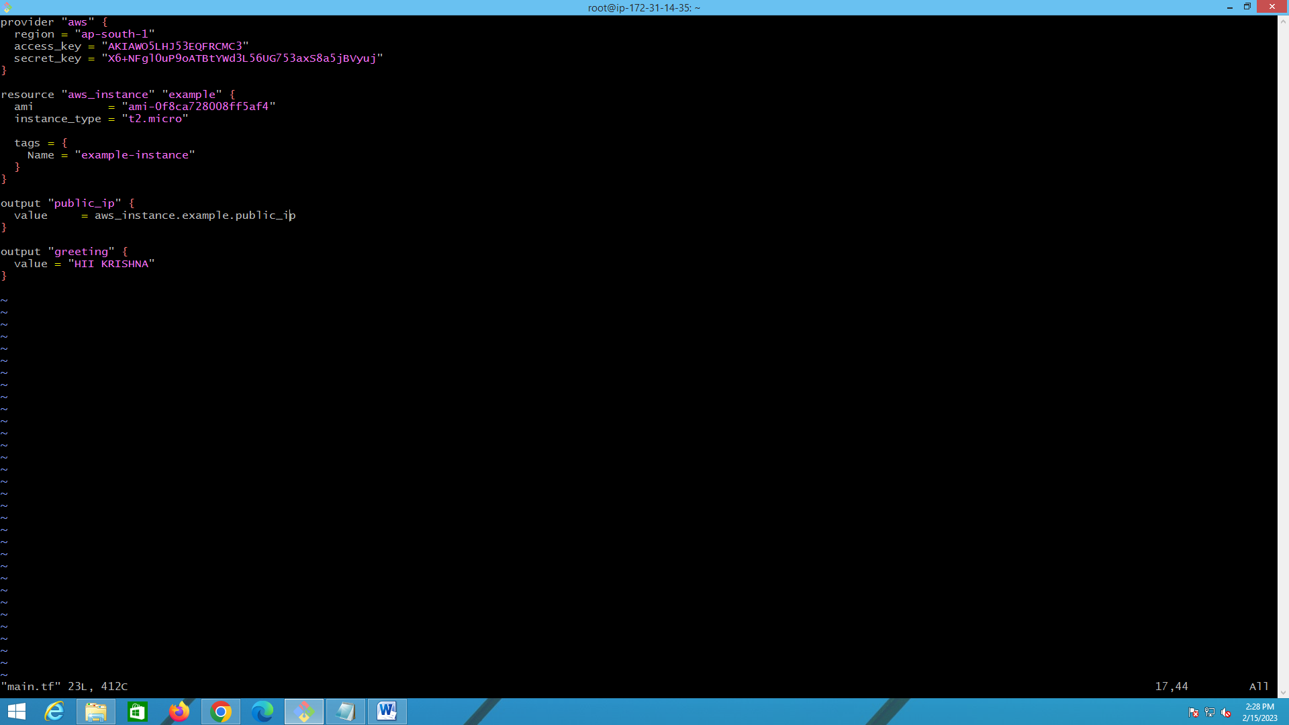



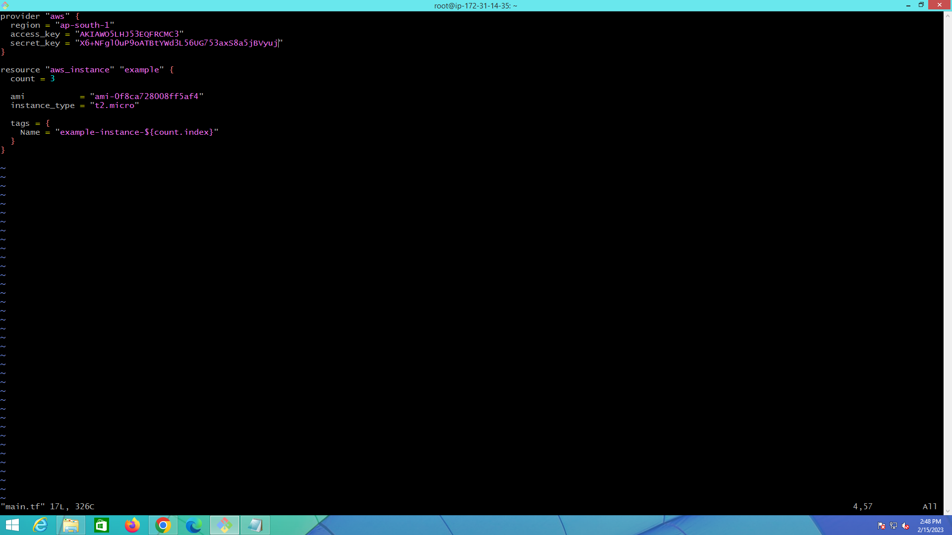

the aws_instance resource is used to create EC2 instances in the ap-south-1 region. The count meta-argument is set to 3, which creates three instances.

The ami attribute specifies the Amazon Machine Image to use for the instances, and the instance_type attribute specifies the instance type to use.

The tags attribute creates a tag for each instance with a unique name that includes the index of the instance (count.index) in the format "example-instance-<index>".

When you run terraform apply with this configuration, Terraform will create three EC2 instances in the specified region, each with a unique name tag.